“When the Sovereign is crowned, he or she is required to place one hand on the open Bible, and is then required to take a solemn oath before Almighty God ‘to uphold to the utmost of my power, the Laws of God within the Realm, and the true profession of the Christian Gospel.’ Parliament, through its peers, pledges itself to support the sovereign in this. This is the British position constitutionally.”
The Coronation Oath
The monarch-to-be is seated upon the Chair of Estate in Westminster Abbey. The Archbishop of Canterbury gives the Coronation Oath for the monarch’s enthronement. The Oath states in part:
Archbishop: “Will you to the utmost of your power maintain the Laws of God and the true profession of the Gospel? Will you to the utmost of your power maintain in the United Kingdom the Protestant Reformed Religion established by law?
Queen: “All this I promise to do.”
The Oath is sealed with a copy of the King James Bible presented to the monarch. The presenter at Queen Elizabeth II’s Coronation was the Moderator of the Church of Scotland, with these words.
“Our gracious Queen: to keep your Majesty ever mindful of the Law and the Gospel of God as the Rule for the whole life and government of Christian Princes, we present you with this Book, the most valuable thing that this world affords. Here is Wisdom [Revelation 13:18]; This is the royal Law [James 2:8]; These are the lively Oracles of God [Acts 7:38, 1 Peter 4:11].”
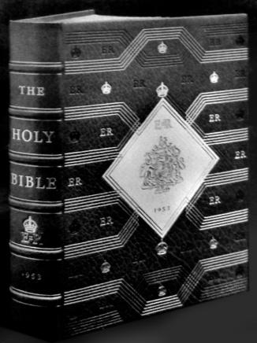
The Coronation Bible and Title Page
“The Royal Law”
James 2:8 states “If ye fulfil the royal law according to the scripture, Thou shalt love thy neighbour as thyself, ye do well:” “The royal law” and “the scripture” are each “the whole law” James 2:10 and the Coronation Oath is unequivocal that the King James Bible is “the royal law” for “the Rule for the whole life and government of” Her Majesty and her subjects. In turn, nothing is above the King James Bible “for thou hast magnified thy word above all thy name” Psalm 138:2.
“The royal law” states in Numbers 15:16* with respect to Great Britain and the Old Dominions that:
“One law and one manner shall be for you, and for the stranger that sojourneth with you.”
*To Israel first but not rescinded for other nations by Paul, the author of specific Christian doctrine
Numbers 15:16 means that for governance of Britain’s inhabitants by “the royal law” the AV1611:
- Criticism of the “the royal law” the AV1611 is treason against God and the Crown.
- Hostility towards Israel and/or the Jewish people is treason against God and the Crown.
- Catholicism by its hatred of “the royal law” the AV1611 is treason against God and the Crown.
- Britain’s membership of the papal European Union is treason against God and the Crown.
- Entry of foreigners alien to “the royal law” the AV1611 is treason against God and the Crown.
- Mohammedanism and all non-Biblical religions are treason against God and the Crown.
- Secular belief systems e.g. Darwinism, Marxism etc. are treason against God and the Crown.
- “Whoremongers...them that defile themselves with mankind...menstealers...liars...perjured persons” 1 Timothy 1:10 “and all that do unrighteously, are an abomination unto the LORD thy God” Deuteronomy 25:16 and traitors to “the royal law” the AV1611, God and the Crown.
The Coronation Oath has been repeatedly violated since the Coronation and it still is.
Continued on next panel

Continued from previous panel
However, as Rev Gardner states, the Oath is “a solemn oath before Almighty God” so God the Offended Party must punish the violators.
God the Offended Party
Men in scripture are likened to trees. “And he looked up, and said, I see men as trees, walking” Mark 8:24.
God promises a judgement by fire in the End Times. “And I will send a fire on Magog, and among them that dwell carelessly in the isles: and they shall know that I am the LORD” Ezekiel 39:6.
“The isles” and “trees, walking” are easily identified.
Jeremiah 21:14 is therefore a grim warning for Britain.
“...I will punish you according to the fruit of your doings, saith the LORD: and I will kindle a fire in the forest thereof, and it shall devour all things round about...”
Proverbs 13:13 is a further warning, though with “mercy...against judgment” James 2:13: “Whoso despiseth the word shall be destroyed: but he that feareth the commandment shall be rewarded.”
Britain must therefore regain her only firebreak “the royal law” the AV1611 to receive mercy when God’s End Times judgement by fire descends “that the whole nation perish not” John 11:50.
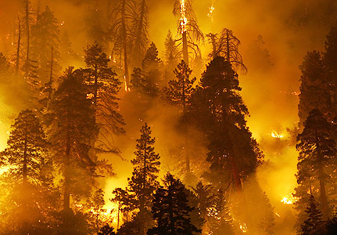
The Fire of Jeremiah
For full text and detailed references:
www.timefortruth.co.uk/why-av-only/
Royal Law – James 2v8
In Sum:
- “The Royal Law” James 2:8, the King James Bible, is Britain’s governance.
- Both church and nation have wickedly departed from the King James Bible.
- God the Offended Party must execute judgement on offenders. “It is time for thee, LORD, to work: for they have made void thy law” Psalm 119:126.
- DON’T be an offender. STICK TO THE BOOK. “...saith the LORD:...to this man will I look, even to him that is poor and of a contrite spirit, and trembleth at my word” Isaiah 66:2.
For more copies of this leaflet:
John Davis, www.timefortruth.co.uk
PO BOX 1146
Kidderminster
Worcs. DY10 1 WG, UK
“The Royal Law” James 2:8
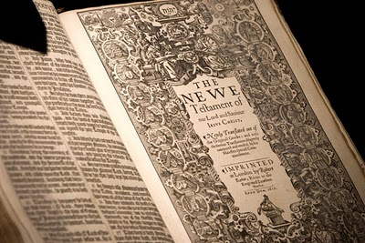
“The Royal Law” James 2:8
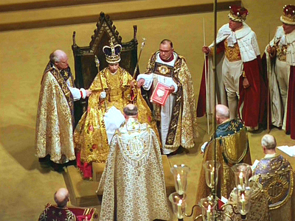
The Queen Enthroned with
“The Royal Law”
British Governance
British governance is embodied in the Coronation Oath. Her Majesty Queen Elizabeth II undertook the Oath when she was crowned. Historian Rev David Gardner explains the significance of the Oath.
Continued overleaf

